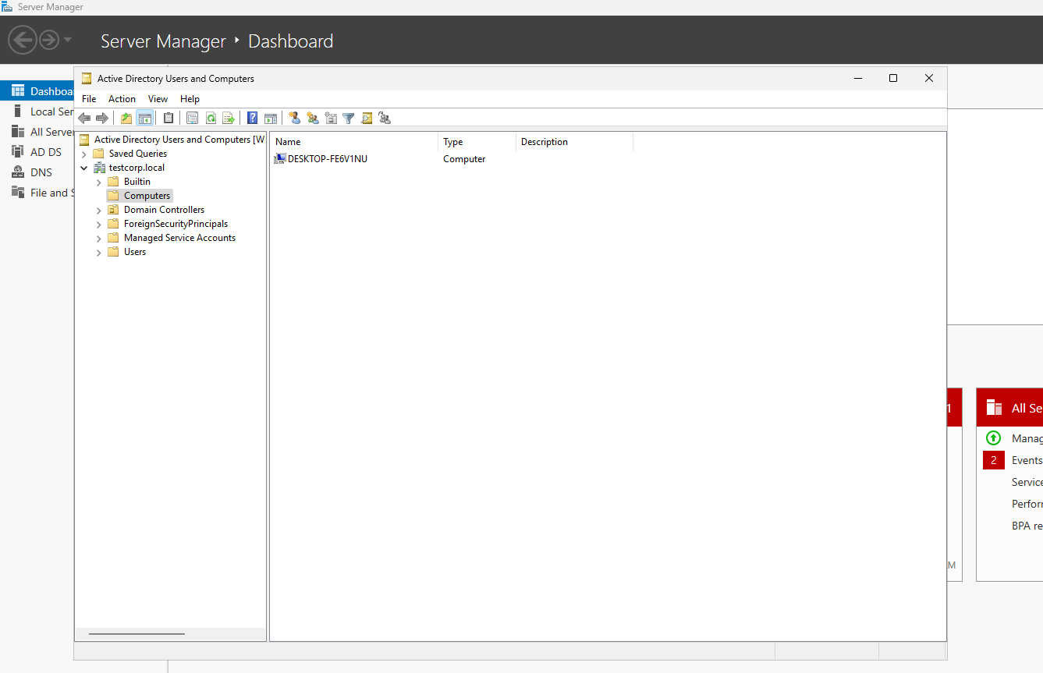
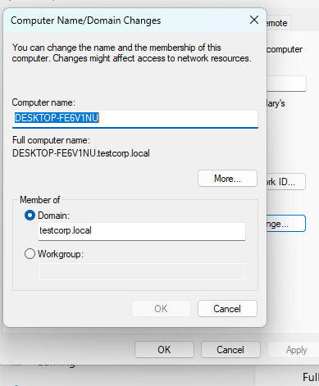
Enrolling a Workstation into the Domain
The workstation was successfully enrolled into the domain using PowerShell.
PowerShell command used:
Add-Computer -DomainName "testcorp.local" -Credential testcorp\testda -Restart
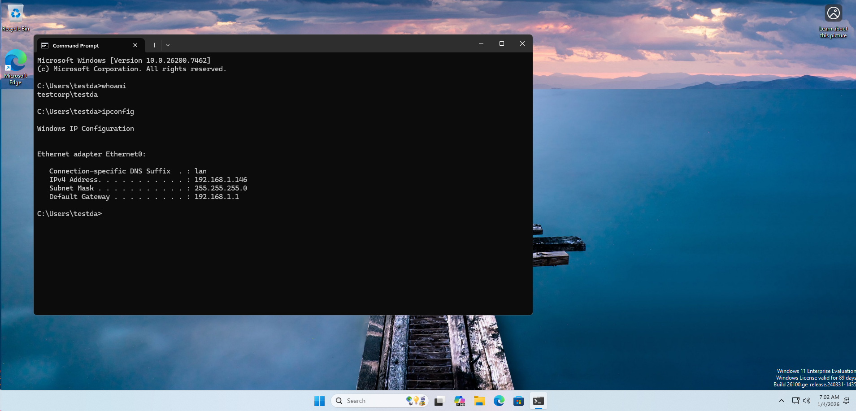
Remote Desktop Verification
A successful Remote Desktop Protocol (RDP) session from the Domain Controller to the workstation confirmed that a Domain Admin account can successfully access and remotely administer the workstation.
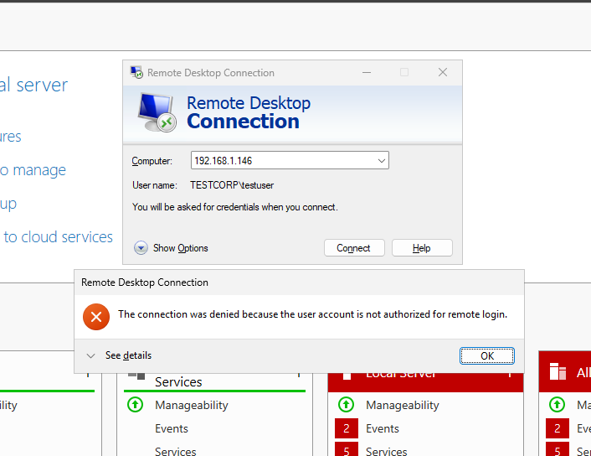
Access Control Verification
A regular, non-administrative user (TestUser) was unable to access the workstation via RDP, confirming that RDP access restrictions were correctly enforced.

